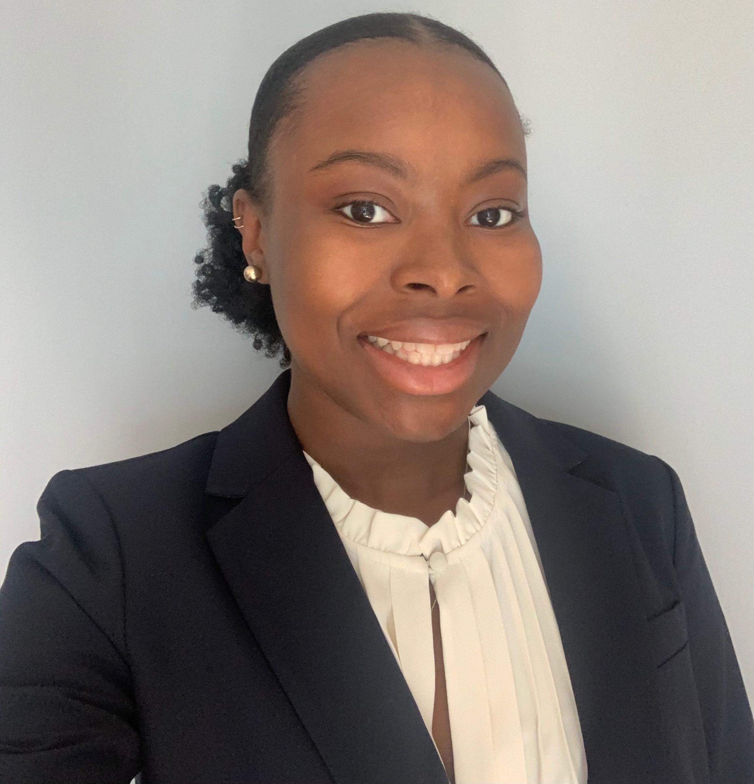
Michaela Taylor is from Upper Marlboro, MD. She graduated from University of Maryland, College Park in 2018 with a dual degree in Biology and Psychology. As an undergraduate she worked with organizations such as Sister to Sister, where she served as a peer mentor, Do Good Challenge, where she completed a project that fundraised and educated her peers on human trafficking, and Humanity First, where she helped develop an educational curriculum that she taught to students in Haiti. Michaela was also involved in research that examined the color discrimination thresholds of the Cichlid fish Metriaclima benetos, which she published in The Journal of Experimental Biology. After graduating, Michaela went on to become a Post Baccalaureate CRTA Fellow at the National Institutes of Health. She studied the interactions of T-Cells and Glucocorticoids through the use of mouse models, cell culture, flow cytometry, CRISPR, and several other techniques. She moved from the NIH to work as a genetic counseling assistant in Inova’s Cancer Genetics Program. Michaela has volunteered at Crisis Textline and as a hospice volunteer. In her free time Michaela enjoys spending time with friends and family, Netflix, video games, reading, listening to podcasts, and finding new adventures with the help of Groupon.

