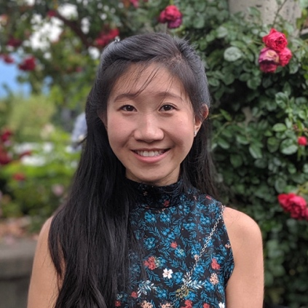

Jacqueline (Jackie) Fung is from New York, NY and graduated from Boston College with a bachelor’s degree in Biology in 2014. While an undergraduate student, she worked in a lab that investigated metabolic therapies for chronic diseases including epilepsy and autism. She was also an active member in various cultural organizations on campus. After graduating, Jackie stayed in Boston and worked in various research positions at Beth Israel Deaconess Medical Center. Her wet-lab experience focused on cancer genetics, while her clinical research experience centered on neurodegenerative diseases. Through her involvement with BIDMC’s Huntington’s Disease Center of Excellence; Cognitive Neurology Unit; and Cancer Genetics and Prevention Program, she discovered the importance of genetic counseling. In her spare time, Jackie enjoys visiting loved ones in NYC and Boston. She is also very fond of baked goods and sweets.

