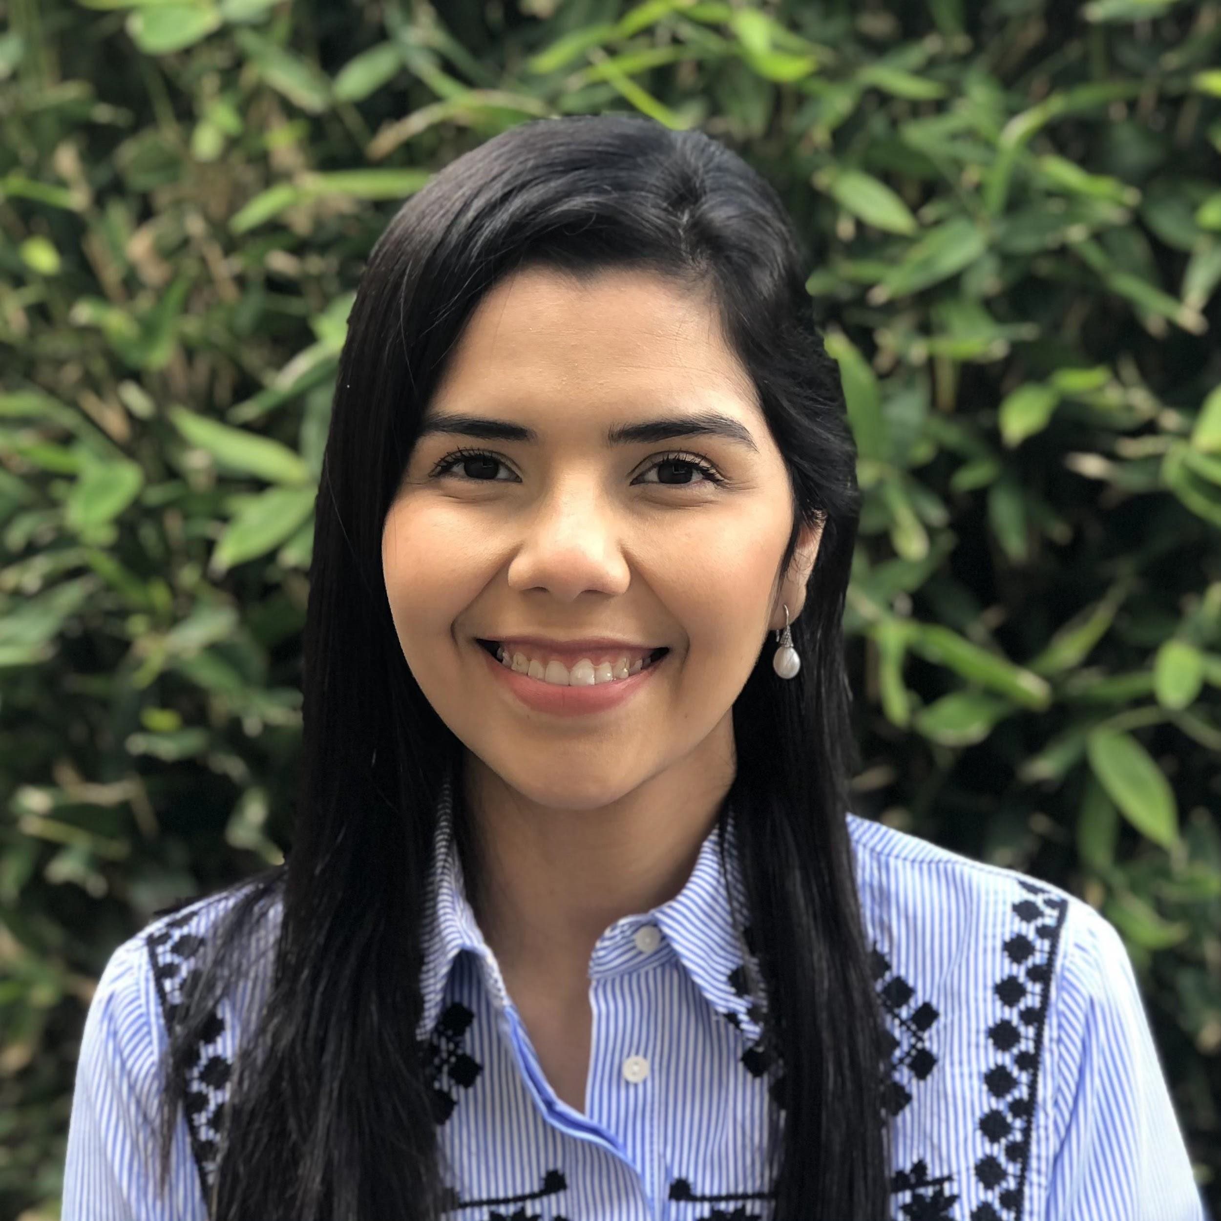
Astrid Torres Zapata is from Castaños Coahuila, Mexico. She received her bachelor's degree in Medicine in 2017 from the Autonomous University of Nuevo Leon, Faculty of Medicine. As an undergraduate, she completed her clinical clerkship at Hospital Universitario Jose Eleuterio Gonzalez, where she gathered patient care experience in internal medicine, psychiatry, obstetrics, pediatrics, among other departments. During her preparation, she worked at the Faculty's Poison Control Center hotline providing information and guidance to health care professionals and the general public regarding poisoning exposures and toxicological emergencies. She also participated in toxicology research, focusing on the clinical management and evolution of crotalic envenomations. After graduation, Astrid volunteered at Samaritan House San Mateo, a non-profit organization, as a medical interpreter. In her free time, she loves to spend time with her dogs, going to museums, visiting new places, hiking, and reading.

